Technical Datasheet of WIN-PiHAT-8DO
1. Overview
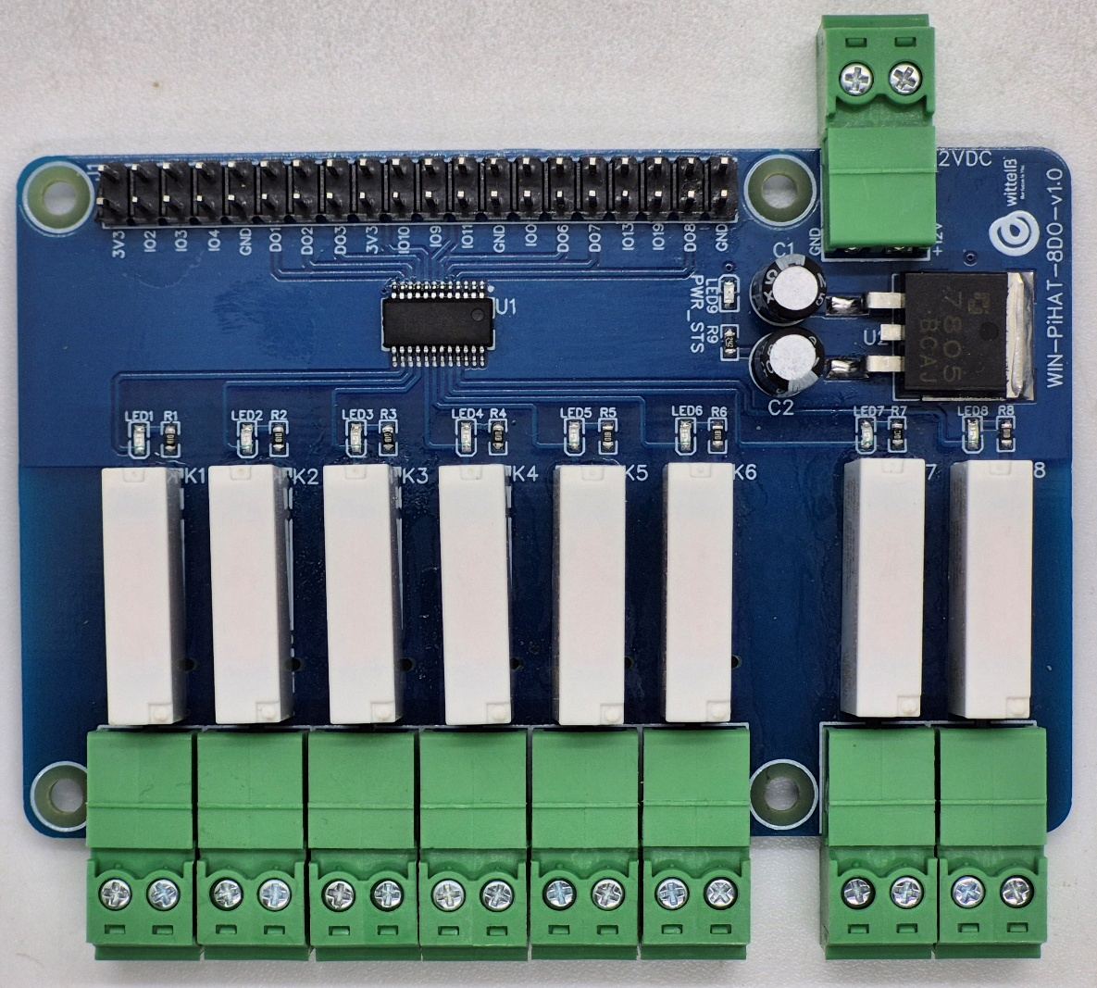
The Digital Output (DO) PiHAT is an 8-channel expansion board for Raspberry Pi 4 and CM4, offering relay-isolated digital outputs for industrial load control. It protects your system by providing electrical isolation between external loads and the Pi’s GPIO header, ensuring reliable operation in industrial environments.
PiHAT features a scalable architecture supporting 1 to 8 independent relay-driven digital outputs (DO). Its population-based design allows channel flexibility while maintaining a compact and reliable solution for embedded control, automation, and industrial load switching applications.
Specifications
Category | 8DO PiHAT
Output Type | Relay-Isolated Digital Outputs,  5V SPST-NO Industrial Relay,  5A @ 250VAC / 30VDC
Channel Count | 8Channels (Expandable Design Architecture)
Connectors | 9 of 2.54 mm Pluggable Terminal Blocks (2-Pin),  40-Pin Raspberry Pi GPIO Header
General :–

Dimensions 56 mm L x 85 mm W
Power Input Power – 12/24V DC
Operating Temperature 0 – 60° C (32 ~ 140°F)
Storage Temperature -20 - 70° C (-4 ~ 158°F)
Storage Humidity 5 ~ 95 % RH, non – Condensing
Certifications 

DO (Digital Outputs) with Relay :–

Channels 8
Contact Form 1A (SPST-NO)
Contact Material AgNi Alloy
Contact Capacity 5A @ 250VAC, 5A @ 30VDC
Coil Voltage 5VDC
Coil Power 0.12W
Insulation Resistance ≥100MΩ
Electrical Life 1 × 10^5 operations
Mechanical Life 1 × 10^7 operations
Operating Time ≤10 ms (max., at rated voltage)
Release Time ≤05 ms (max., at rated voltage)

Configuration :-

All 8 DO channels operate as relay-driven digital outputs and are interfaced to the Raspberry Pi GPIO header through a Darlington transistor array. Output control is performed via software running on the Raspberry Pi. Each channel is configured as a GPIO output and drives a corresponding relay.

When a GPIO pin is driven HIGH, the Bipolar Transistor sinks current through the relay coil, energizing the relay and closing the Normally Open (NO) contact. When the GPIO pin is driven LOW, the relay coil is de-energized and the contact returns to its default open state.

The following are step by step guides for configuration:
- Connect the Module to +12/24V DC POWER SUPPLY.
- Connect the Board to the Raspberry Pi via header pins

Sr. No. | Digital Input | Pi GPIO | Header Pin number
1 | D01 | 17 | 11
2 | D02 | 27 | 13
3 | D03 | 22 | 15
4 | D04 | 24 | 18
5 | D05 | 25 | 22
6 | D06 | 05 | 29
7 | D07 | 06 | 31
8 | D08 | 26 | 37

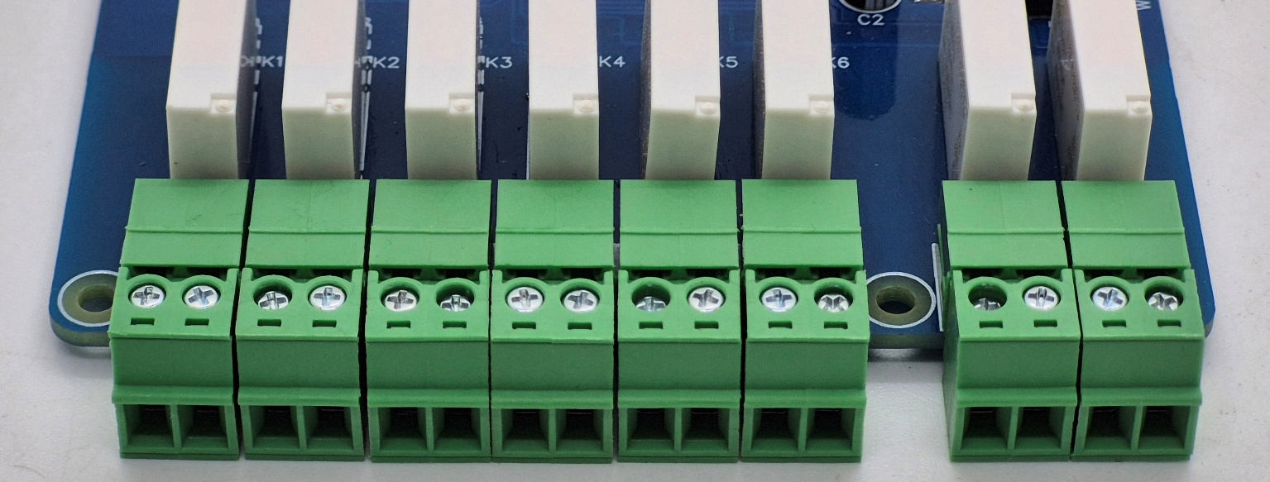




Wiring Diagram:-
Load
C1 NO1 C3 NO3 C5 NO5 C7 NO7
Load
Load
Load

- For Digital Output (DO) operation, each channel provides two terminals: C (Common) and NO (Normally Open). When the relay is energized, terminal C is internally connected to NO. When the relay is de-energized, the connection between C and NO is open.
- For AC load connection, the AC Live (Phase) wire is connected to terminal C, and the load is connected between terminal NO and Neutral. For DC load connection, the positive supply (+V) is connected to terminal C, and the load is connected between terminal NO and Ground.
- It is recommended to switch the Live (Phase) conductor to AC applications. Ensure that the connected load does not exceed the relay rating of 5A 250VAC or 5A @30VDC.
Sample Test Code:
- WIN-PiHAT-8DO(Relay)
Hardware Interface & Connector Layout:
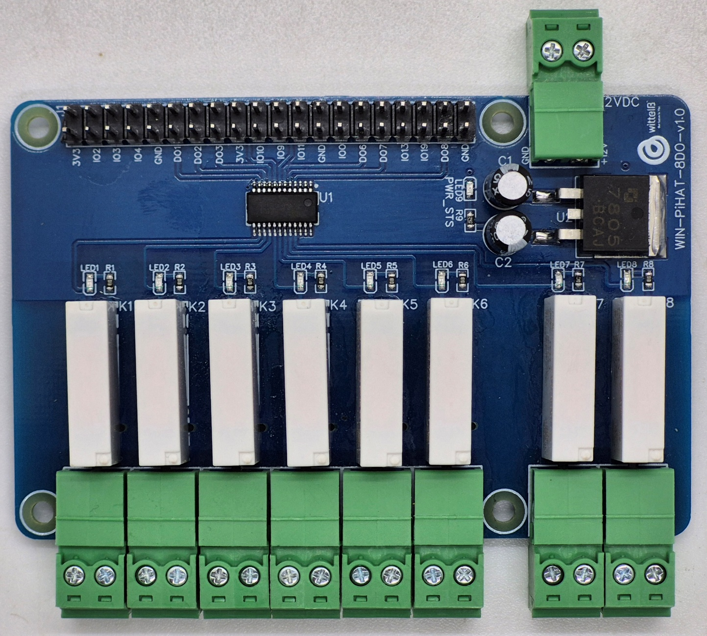
40 pin GPIO Headers
NO1-NO8 Normally Open
12/24V DC Supply
C1-C8 COM
2
1
40
39

Contact us: -
Augmatic Technologies Pvt. Ltd.,
Plot no 6, Shah Industrial Estate II,
Kotambi,
Vadodara – 391510.
Email – Sales@wittelb.com

